*Heaven’s light is our guide.*

****Rajshahi University of Engineering and Technology**

**

**Department of Electrical & Electronic Engineering**

**Course no.** EEE3204

**Course title:** Power Electronics Sessional

**Experiment no.** 01

**Experiment name:** Performance analysis of half-wave rectifier with resistive & inductive load

**Date of experiment:** October 15,2022

**Date of submission:** October 29,2022

|  |  |
| --- | --- |
| **Submitted to:** | **Submitted by:** |
| **Md. Abdul Malek**  **Assistant Professor**  Dept. of Electrical & Electronic Engineering,  Rajshahi University of Engineering and Technology. | **Ashraf Al- Khalique**  **Roll:** 1801171  **Session:** 2018-2019  Dept. of Electrical & Electronic Engineering,  Rajshahi University of Engineering and Technology. |

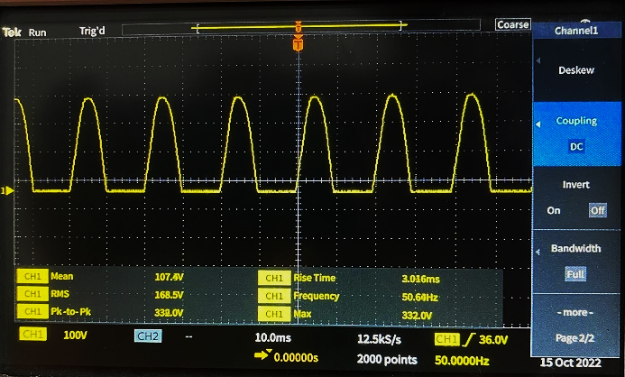

*Fig: Voltage across resistive load (DC Coupling)*

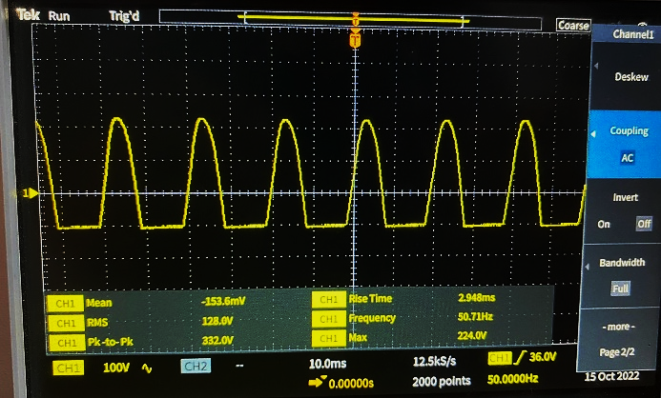

*Fig: Voltage across resistive load (AC Coupling)*

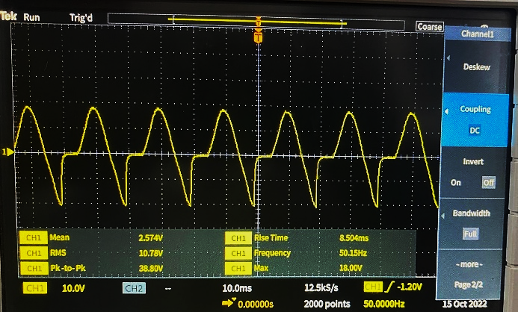

*Fig: Voltage across Inductive load (DC Coupling)*

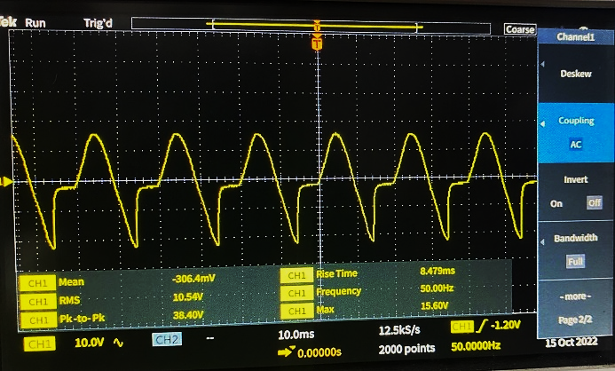

*Fig: Voltage across Inductive load (AC Coupling)*

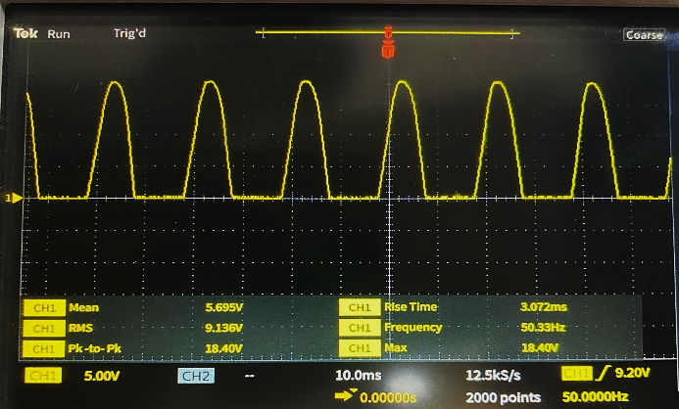

*Fig: Voltage across resistive load in series with Inductive load (DC Coupling)*